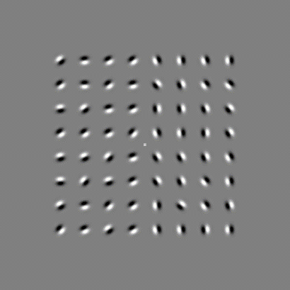

**SIGNAL (Increasing Noise Level)**

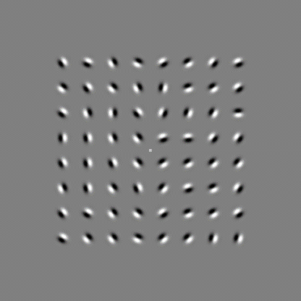

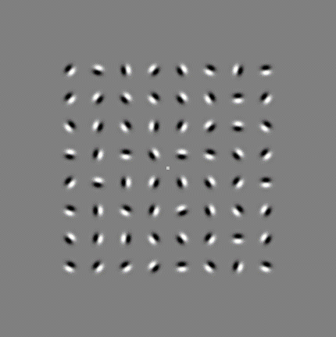

**NO SIGNAL**

|  |  |  |  |  |  |  |  |  |  |
| --- | --- | --- | --- | --- | --- | --- | --- | --- | --- |
| **#** | **Layer Type** | **Network (1)** | | **Network (2)** | **Network (4)** | **Network (8)** | **…** | | **Network (128)** |
| 1 | Input (min size x, min size y, channels) | | 128,128, 1 | 128,128, 1 | 128,128, 1 | 128,128, 1 |  | | 128,128, 1 |
| 2 | Convolution (size x, size y, count) | | 11,11,1 | 11,11,2 | 11,11,4 | 11,11,8 |  | | 11,11,128 |
| 3 | Activation Layer | | “ReLU” | “ReLU” | “ReLU” | “ReLU” |  | | “ReLU” |
| 4 | Max pool | | 2,2 | 2,2 | 2,2 | 2,2 |  | | 2,2 |
| 5 | Flatten | |  |  |  |  |  | |  |
| 6 | Dropout | | 0.5 | 0.5 | 0.5 | 0.5 |  | | 0.5 |
| 7 | Output (count) | | 1 | 1 | 1 | 1 |  | | 1 |
|  |  | |  |  |  |  |  |  | |

|  |  |  |  |  |  |  |  |  |
| --- | --- | --- | --- | --- | --- | --- | --- | --- |
| **#** | **Layer Type** | **Network (3x3)** | | **Network (5x5)** | **Network (7x7)** | **Network (9x9)** | **…** | **Network (19x19)** |
| 1 | Input (min size x, min size y, channels) | | 128,128, 1 | 128,128, 1 | 128,128, 1 | 128,128, 1 |  | 128,128, 1 |
| 2 | Convolution (size x, size y, count) | | 3,3,32 | 5,5,32 | 7,7,32 | 9,9,32 |  | 19,19,32 |
| 3 | Activation Layer | | “ReLU” | “ReLU” | “ReLU” | “ReLU” |  | “ReLU” |
| 4 | Max pool | | 2,2 | 2,2 | 2,2 | 2,2 |  | 2,2 |
| 5 | Flatten | |  |  |  |  |  |  |
| 6 | Dropout | | 0.5 | 0.5 | 0.5 | 0.5 |  | 0.5 |
| 7 | Output (count) | | 1 | 1 | 1 | 1 |  | 1 |

|  |  |  |  |  |  |  |
| --- | --- | --- | --- | --- | --- | --- |
| **#** | **Layer Type** | **Network (1)** | | **Network (4)** | **Network (8)** | **Network (32)** |
| 1 | Input (min size x, min size y, channels) | | 128,128, 1 | 128,128, 1 | 128,128, 1 | 128,128, 1 |
| 2 | Convolution (size x, size y, count) | | 13,13,1 | 13,13,4 | 13,13,8 | 13,13,32 |
| 3 | Activation Layer | | “ReLU” | “ReLU” | “ReLU” | “ReLU” |
| 4 | Max pool | | 2,2 | 2,2 | 2,2 | 2,2 |
| 5 | Flatten | |  |  |  |  |
| 6 | Dropout | | 0.5 | 0.5 | 0.5 | 0.5 |
| 7 | Output (count) | | 1 | 1 | 1 | 1 |

|  |  |  |  |
| --- | --- | --- | --- |
| **#** | **Layer Type** | **Dual Layer** | **Reverse Dual Layer** |
| 1 | Input (min size x, min size y, channels) | 128,128, 1 | 128,128, 1 |
| 2 | Convolution (size x, size y, count) | 13,13,32 | 5,5,32 |
| 3 | Activation Layer | “ReLU” | “ReLU” |
| 4 | Max pool | 2,2 | 2,2 |
| 5 | Convolution (size x, size y, count) | 3,3,16 | 13,13,16 |
| 6 | Activation Layer | “ReLU” | “ReLU” |
| 7 | Max pool | 2,2 | 2,2 |
| 8 | Flatten |  |  |
| 9 | Dropout | 0.5 | 0.5 |
| 10 | Output (count) | 1 | 1 |

|  |  |  |  |  |  |  |  |  |  |  |  |  |
| --- | --- | --- | --- | --- | --- | --- | --- | --- | --- | --- | --- | --- |
| **#** | **Layer Type** | **Network (1)** | | **Network (2)** | **Network (3)** | **Network (4)** | | **Network (5)** | | | | |
| 1 | Input (min size x, min size y, channels) | | 128,128, 1 | 128,128, 1 | 128,128, 1 | 128,128, 1 | | 128,128, 1 | | | | |
| 2 | Convolution (size x, size y, count) | | 11,11,32 | 11,11,32 | 11,11,32 | 11,11,32 | | 11,11,32 | | | | |
| 3 | Convolution (size x, size y, count) | | - | 3,3,16 | 3,3,16 | 3,3,16 | | | 3,3,16 | | |
| 4 | Convolution (size x, size y, count) | | - | - | 3,3,8 | | 3,3,8 | | | 3,3,8 |
| 5 | Convolution (size x, size y, count) | | - | - | - | 3,3,8 | | 3,3,8 | | | | |
| 6 | Convolution (size x, size y, count) | | - | - | - | - | | 3,3,8 | | | | |
| 7 | Flatten | |  |  |  |  | |  | | | | |
| 8 | Dropout | | 0.5 | 0.5 | 0.5 | 0.5 | | 0.5 | | | | |
| 9 | Output (count) | | 1 | 1 | 1 | 1 | | 1 | | | | |

|  |  |  |  |
| --- | --- | --- | --- |
|  |  | **Ground Truth (Large)** | |
|  |  | **Signal** | **No Signal** |
|  | **Signal** | 1088 (43.6%) | 130 (5.2%) |
| **No Signal** | 166 (6.6%) | 1114 (44.6%) |

**Prediction**

**Accuracy (%)**

**No. Epochs**